**A Mini- Project Report**

**on**

**“STAY PLANNER- Hotel Booking System”**

Submitted to the

PES Modern College of Engineering, Pune

In partial fulfillment for the award of the Degree of

Bachelor of Engineering

in

Information Technology

by

|  |  |  |
| --- | --- | --- |
| **Vaibhav Laxman Gawas** |  | **35023** |
| **Omkar Arun Gore** |  | **35024** |
| **Kaustubh Gajanan Indulkar** |  | **35026** |
| **Siddhesh Satish Jagtap** |  | **35030** |

Under the guidance of

**Prof. Kasturi Nikumbh**



Department Of Information Technology

PES’s Modern College of Engineering,

Pune - 411005

**2023-2024**

**CERTIFICATE**

                 This is to certify that the project report entitled

**“** **STAY PLANNER- Hotel Booking System”**

**Submitted by**

|  |  |  |
| --- | --- | --- |
| **Vaibhav Laxman Gawas** |  | **35023** |
| **Omkar Arun Gore** |  | **35024** |
| **Kaustubh Gajanan Indulkar** |  | **35026** |
| **Siddhesh Satish Jagtap** |  | **35030** |

is a bonafide work carried out by them under the supervision of **Prof.Kasturi Nikumbh** and it is approved for the partial fulfillment of the requirement of Web Application Development Laboratory- 2019 Course for the award of the Degree of Bachelor of Engineering (Information Technology),Savitribai Phule Pune University.

|  |  |
| --- | --- |
| **Prof. Kasturi Nikumbh** | **Dr. Mrs.S.D.Deshpande** |
| Internal Guide | Head of Department |
| Department of Information Technology | Department of Information Technology |
|  |  |
|  |  |
|  |  |

Place: Pune

Date: 15/04/2024

I

**ACKNOWLEDGEMENT**

I would like to take this opportunity to express my gratitude towards all those who helped me in accomplishing this Web Application Development Laboratory work. First of all I would like to thank P. E. S. 's Modern College of Engineering for giving me this opportunity to look at some concepts from Web Application Development, my curriculum subject. I would like to thank my guide **Prof. Kasturi Nikumbh** for her valuable comments and timely support. I would like to show my greatest appreciation to her.

I would also like to thank all other faculty members for supporting me directly or indirectly. The guidance and support received from all the Professors who contributed are vital for the success of the work. I am grateful for their constant support and help. Lastly, I would like to thank my friends for their support and encouragement.

**NAME OF GROUP MEMBERS:**

1. 35023: Vaibhav Laxman Gawas
2. 35024: Omkar Arun Gore
3. 35026: Kaustubh Gajanan Indulkar
4. 35030: Siddhesh Satish Jagtap

II

**LIST OF FIGURES**

|  |  |  |
| --- | --- | --- |
| **Sr.no** | **Title of Figure** | **Page.no** |
| 1 | Home Page | 15 |
| 2 | Places | 15 |
| 3 | User Profile Page | 16 |
| 4 | Bookings Page | 16 |
| 5 | Accommodation Page | 17 |

III

**Abstract**

The **"STAY PLANNER-Hotel Booking System"** is a mini project aimed at streamlining and modernizing the hotel reservation process. In today's fast-paced digital age, the hospitality industry relies on efficient and user-friendly systems to meet the needs of tech-savvy travelers. This project is centered around the development of a hotel booking system that leverages the MERN (MongoDB, Express.js, React, Node.js) stack for its construction. The MERN stack is a powerful combination of technologies that covers the entire web application development spectrum, offering a versatile and efficient framework for building robust systems. The system provides a user-friendly interface for customers to explore and book hotel rooms and equips hotel administrators with tools to manage bookings, room availability, and customer information. By utilizing MongoDB for data storage, Express.js for the server, React for the frontend, and Node.js for server-side scripting, the project ensures efficient data management, data retrieval, and seamless user experiences. The MERN stack's flexibility and scalability make it suitable for accommodating a growing user base and expanding hotel portfolios. This mini project serves as an exemplar of how modern web development technologies can be harnessed to create a sophisticated and user-centric hotel booking system that meets the demands of today's digital traveler.

IV

**CONTENTS**

CERTIFICATE                                                                                I

ACKNOWLEDGEMENT                                                              II

LIST OF FIGURES                                                                      III

ABSTRACT IV

|  |  |  |
| --- | --- | --- |
| **Sr.No** | **Title** | **Page No.** |
| 1 | INTRODUCTION | 7-8 |
| 2 | BACKGROUND AND LITERATURE SURVEY | 9-10 |
|  |
| 3 | REQUIREMENT SPECIFICATION AND ANALYSIS | 11-12 |  |
| 4 | DESIGN AND  IMPLEMENTATION | 13-14 |  |
| 5 | OPTIMIZATION AND  EVALUATION | 15-16 |  |
| 6 | RESULT | 17-19 |  |
| 7 | CONCLUSIONS AND  FUTURE WORK | 20-21 |  |
| 8 | REFERENCES | 22 |  |

|  | |  |  |  |
| --- | --- | --- | --- | --- |
|  |  |  | |  |
|  | |  |  |  |
|  |  |  |
|  |  | |  |  |
|  |  | |  |  |
|  |  |  |  |  |
|  |  |  |  |  |
|  | |  |  |  |
|  | |  |  |  |
|  | |  |  |  |
|  | |  |  |  |
|  |  |  |  |  |
|  |  |  |  |  |
|  |  |  |  |  |
|  |  |  |  |  |
|  |  |  |  |  |
|  |  |  |  |  |
|  |  |  |  |  |
|  |  |  |  |  |
|  |  |  |  |  |
|  |  |  |  |  |
|  |  |  |  |  |
|  |  |  |  |  |
|  |  |  |  |  |
|  |  |  |  |  |
|  |  |  |  |  |
|  |  |  |  |  |
|  |  |  |  |  |
|  |  |  | |  |
|  |  |  |  |  |
|  |  |  |  |  |
|  |  |  |  |  |

**STAY PLANNER- Hotel Booking System**

1. **INTRODUCTION**

In an era defined by digital transformation and the rapid evolution of technology, the hospitality industry is no exception to the fundamental shifts in consumer behavior. With travelers increasingly relying on the convenience and accessibility of online platforms for their hotel reservations, it is imperative for hotels and accommodations to offer efficient and user-friendly booking systems. Our mini project, titled "Hotel Booking System Using MongoDB," addresses this need by developing a modern and robust hotel booking system.

This report introduces the key components and objectives of the project, emphasizing the pivotal role that MongoDB plays in the design and implementation of the system. In the sections that follow, we will explore the specific goals, features, and technologies involved in creating a hotel booking system that leverages the power of MongoDB as its backend database.

**1.1 Background**

The hotel industry has witnessed a paradigm shift with the advent of online reservation systems. Modern travelers prefer the flexibility of browsing, comparing, and booking hotel rooms from the comfort of their computers or mobile devices. Hotel booking systems have become critical tools in offering a seamless, user-centric experience for customers while streamlining operations for hotel administrators.

**1.2 Project Objectives**

Our project's primary objective is to design and develop a hotel booking system that is efficient, user-friendly, and adaptable to the evolving needs of both customers and hotel management. This system is built on the foundation of MongoDB, a NoSQL database that excels in handling dynamic and diverse data, making it a fitting choice for storing complex hotel-related information.

**1.3 Key Features**

The hotel booking system will cater to both customers and hotel administrators. It will provide customers with a user-friendly platform to browse available rooms, make reservations, and access booking information. Hotel administrators, on the other hand, will be equipped with tools for managing room availability, monitoring bookings, and maintaining customer records.

**1.4 Technology Stack**

MongoDB serves as the backbone of the system, allowing for flexible data storage and retrieval. Additionally, we will employ Python to build the application, integrating it seamlessly with MongoDB to ensure data organization, security, and scalability.

**1.5 Scope of the Report**

This report will delve into the various aspects of the project, including system architecture, features, and user interfaces. It will also discuss the advantages of using MongoDB in a hotel booking system and how Python is employed to create a dynamic and responsive application.

As we progress through this report, we will provide an in-depth exploration of each project component and its contribution to achieving a streamlined, efficient, and user-centric hotel booking system. The subsequent sections will elaborate on the development, implementation, and outcomes of the project.

1. **BACKGROUND AND LITERATURE SURVEY**

**2.1 Introduction**

The hospitality industry is undergoing a digital transformation, driven by the increasing adoption of technology by travelers. Modern travelers expect convenient and user-friendly online booking systems. This literature review explores the development of a hotel booking system using the MERN stack (MongoDB, Express.js, React.js, Node.js) to address this growing demand.

**2.2 MERN Stack for Hotel Booking Systems**

Several studies highlight the suitability of the MERN stack for developing hotel booking systems due to its features:

**2.3 MERN Stack for Hotel Booking Systems**

Several studies highlight the suitability of the MERN stack for developing hotel booking systems due to its features:

* **Full-Stack Development:** The MERN stack provides all the necessary components for web development, from data storage (MongoDB) to server-side scripting (Node.js) and user interface (React.js). This simplifies development and reduces the need for integrating various technologies
* **Scalability and Flexibility:** The MERN stack scales well to accommodate a growing user base and expanding hotel listings.
* **User-friendly Interface:** React.js enables the creation of dynamic and interactive user interfaces, enhancing the customer experience.
* **Efficient Data Management**: MongoDB's NoSQL structure is well-suited for storing and retrieving hotel data like room details, bookings, and customer information

**2.4 Focus of the Proposed Project**

The project builds upon the existing knowledge by focusing on developing a **mini hotel booking system** using the MERN stack. This mini-project can serve as a valuable learning tool for understanding the functionalities and implementation of such a system.

* **User functionalities:** Explore features like room search, booking confirmation, cancellation options, and integration with payment gateways.
* **Admin functionalities:** Develop functionalities for managing room availability, bookings, customer information, and potentially generating reports.
* **Security considerations:** Implement user authentication and authorization mechanisms to ensure data security.
* **User Interface (UI) and User Experience (UX) Design:** Design an intuitive and user-friendly interface for both customers and administrators.

**Conclusion**

This literature review highlights the advantages of using the MERN stack for developing hotel booking systems. The proposed mini-project contributes by providing a practical application of this technology stack in a smaller, focused implementation. By focusing on user needs, functionalities, and security considerations, you can create a valuable learning experience and demonstrate the potential of the MERN stack in the hospitality industry.

1. **REQUIREMENT SPECIFICATION AND ANALYSIS**

**3.1 Introduction**

**3.1.1 Purpose**

The purpose of this document is to define the functional and non-functional requirements for the development of a Hotel Booking system utilizing MongoDB as the database

management system. This system aims to provide a basic online platform for booking hotel rooms.

**3.1.2 Scope**

This system will cover the core functionalities necessary for a hotel booking application, including user registration, room booking, and basic administration of available rooms.

**3.2 Functional Requirements**

**3.2.1 User Registration and Authentication**

- Users shall be able to register for an account by providing basic information such as name, email, and password.

- Registered users can log in using their email and password.

- Users should receive a confirmation email upon successful registration.

**3.2.2 Hotel Room Booking**

- Users can search for available hotels based on location, check-in, and check-out dates.

- The system shall provide a list of available rooms at the selected hotel.

- Users can select a room and make a booking.

- Users should receive a booking confirmation with booking details.

**3.2.3 Room Management**

- Administrators can add, update, or delete room information, including room type, capacity, price, and availability.

- Admins can mark rooms as available or unavailable for booking.

1. **Non-Functional Requirements**

**3.3 Performance**

- The system should provide a responsive user experience with minimal latency.

- The system must be able to handle multiple users concurrently.

**3.4 Security**

- User data and passwords must be securely stored and hashed.

- Administrative functions should be accessible only to authorized administrators.

**4. DESIGN AND  IMPLEMENTATION**

**4.1 Project Objectives**

* Develop a simplified hotel booking system using the MERN stack.
* Enable users to search for hotels, make bookings, and manage reservations.
* Utilize MongoDB as the database management system.
* Create a user-friendly web interface for both customers and administrators.

**4.2 Project Phases**

**Phase 1: Project Initiation**

* Define the project scope, objectives, and deliverables.
* Identify stakeholders and establish communication channels.
* Assemble the project team and allocate roles.
* Develop a project charter.
* Set up development and testing environments.
* Define the high-level project milestones and timeline.

**Phase 2: Requirements and Design**

* Gather and document detailed system requirements.
* Create a Software Requirement Specification (SRS).
* Develop wireframes and design mockups.
* Define the database schema.
* Finalize the architecture and technology stack.
* Create a comprehensive design document.

**Phase 3: Development**

* Develop the frontend using React.
* Build the backend using Node.js and Express.js.
* Implement user authentication and authorization.
* Integrate MongoDB for data storage.
* Develop search, booking, and reservation management features.
* Conduct iterative testing and code reviews during development.
* Prepare user documentation.

**Phase 4: Testing**

* Conduct functional testing of the entire system.
* Perform usability and user acceptance testing.
* Identify and address issues and defects.
* Test system performance and security.
* Generate a testing report with results and issues.

**Phase 5: Deployment**

* Deploy the system to a production server.
* Configure the server environment for security and performance.
* Implement backups and data recovery procedures.
* Prepare for the system's go-live.

**5. OPTIMIZATION AND  EVALUATION**

This project description outlines a promising hotel booking system built with the MERN stack.

**5.1 Optimization:**

* **User Interface (UI) and User Experience (UX):**
  + Conduct user testing to identify and refine the user interface for both guests and hotel administrators.
  + Ensure the booking process is intuitive, efficient, and caters to mobile responsiveness for on-the-go reservations.
  + Consider accessibility features for users with disabilities.
* **Functionality:**
  + Implement features like search filters (price, amenities, location), guest reviews, and room image galleries to enhance the user experience for guests.
  + Explore integrating with payment gateways for secure online transactions.
  + Develop functionalities for managing cancellations, modifications, and special requests from guests.
  + Include reporting tools for hotel administrators to track booking trends, occupancy rates, and revenue.
* **Performance:**
  + Optimize code for speed and responsiveness, especially for user interactions and data retrieval.
  + Consider implementing caching mechanisms for frequently accessed data to improve loading times.
  + Test the system under load to ensure it can handle peak booking periods.

**5.2 Evaluation:**

* **Functionality Testing:**
  + Meticulously test all functionalities from both guest and administrator perspectives.
  + Simulate various booking scenarios and edge cases to identify and fix any bugs.
* **Usability Testing:**
  + Conduct usability testing with a representative set of users to identify any pain points or areas for improvement in the booking process and overall user experience.
* **Security Testing:**
  + Conduct thorough security testing to identify and address any vulnerabilities in the system, especially regarding guest data and financial transactions.
* **Performance Testing:**
  + Test the system under load to evaluate its performance under peak booking periods. Measure response times and identify any bottlenecks that need optimization.

**5.3 Additional Considerations:**

* **Scalability:**
  + Ensure the system architecture can be scaled horizontally to accommodate a growing user base and hotel portfolio. This might involve using cloud-based solutions for data storage and server infrastructure.
* **Maintainability:**
  + Implement clean code practices, modular design, and proper documentation to ensure the system is maintainable and easy to update in the future.
* **Deployment Strategy:**
  + Define a clear deployment strategy, including version control, continuous integration/continuous delivery (CI/CD) pipelines, and a disaster recovery plan.

**6. RESULT**

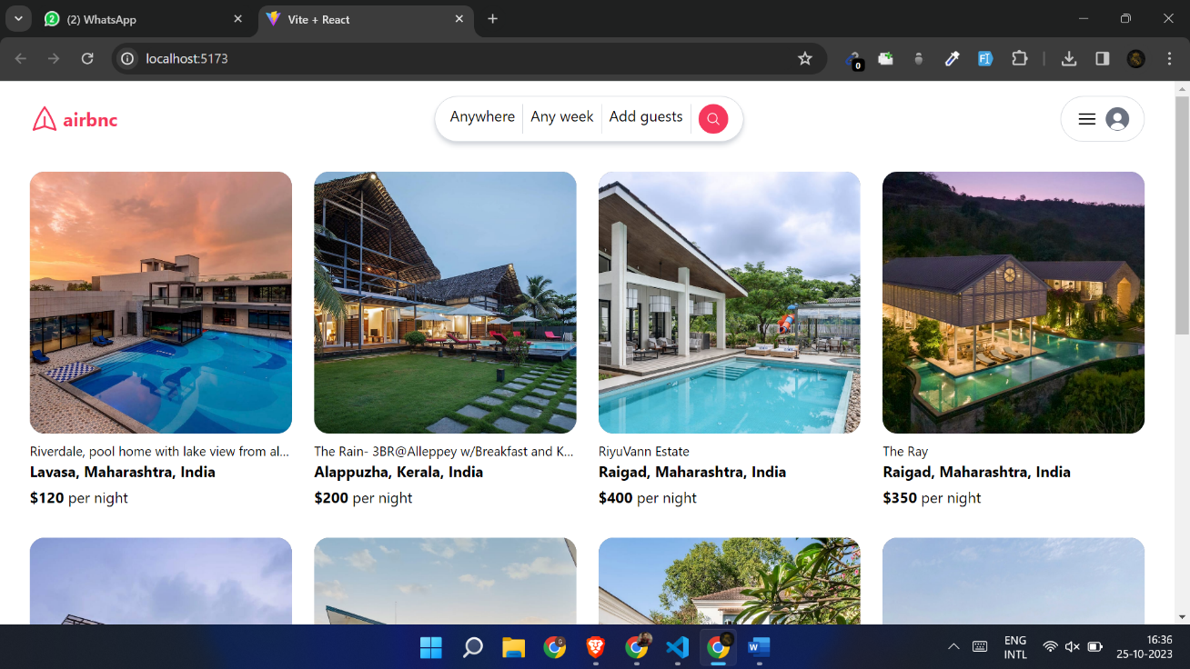

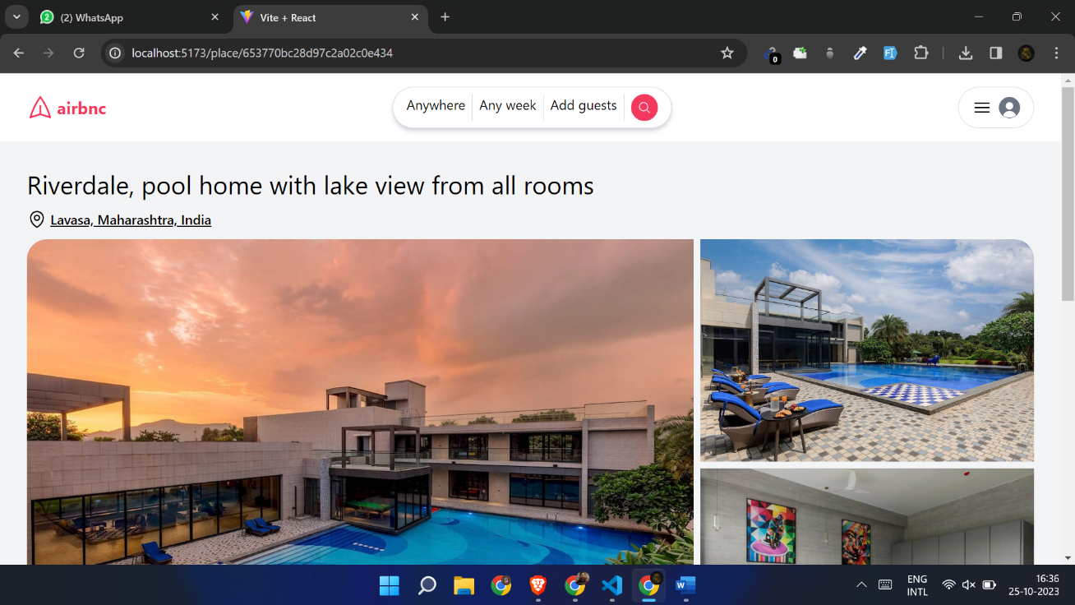

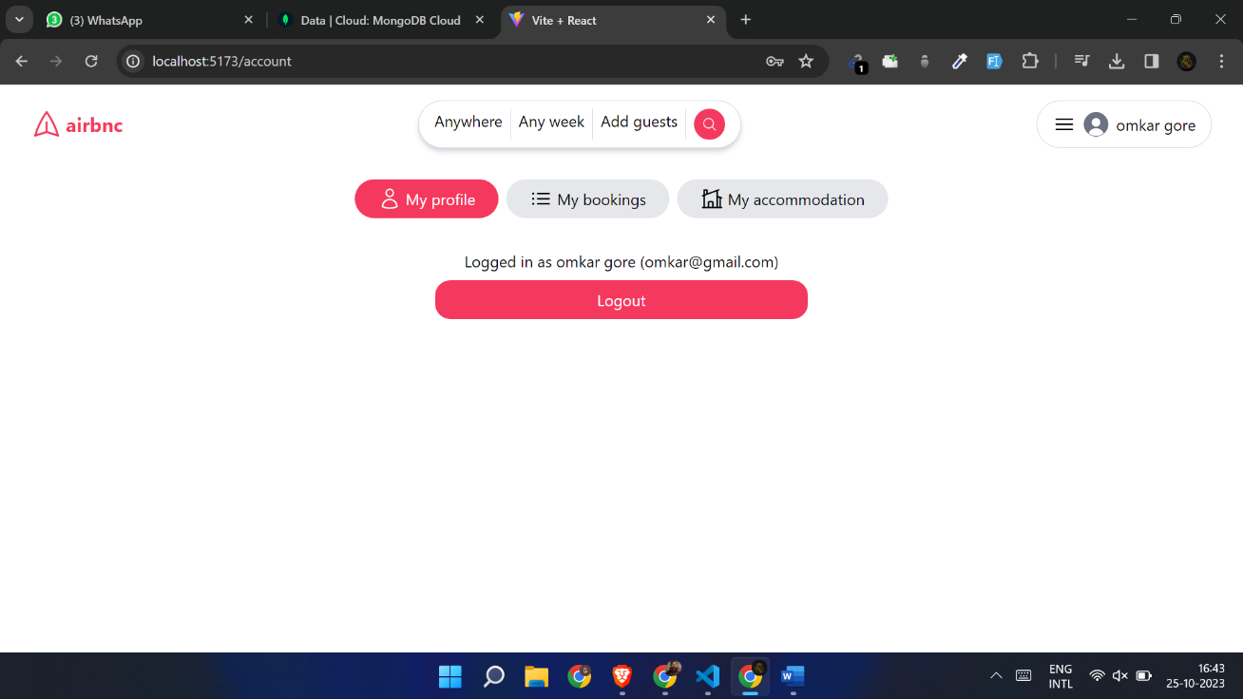

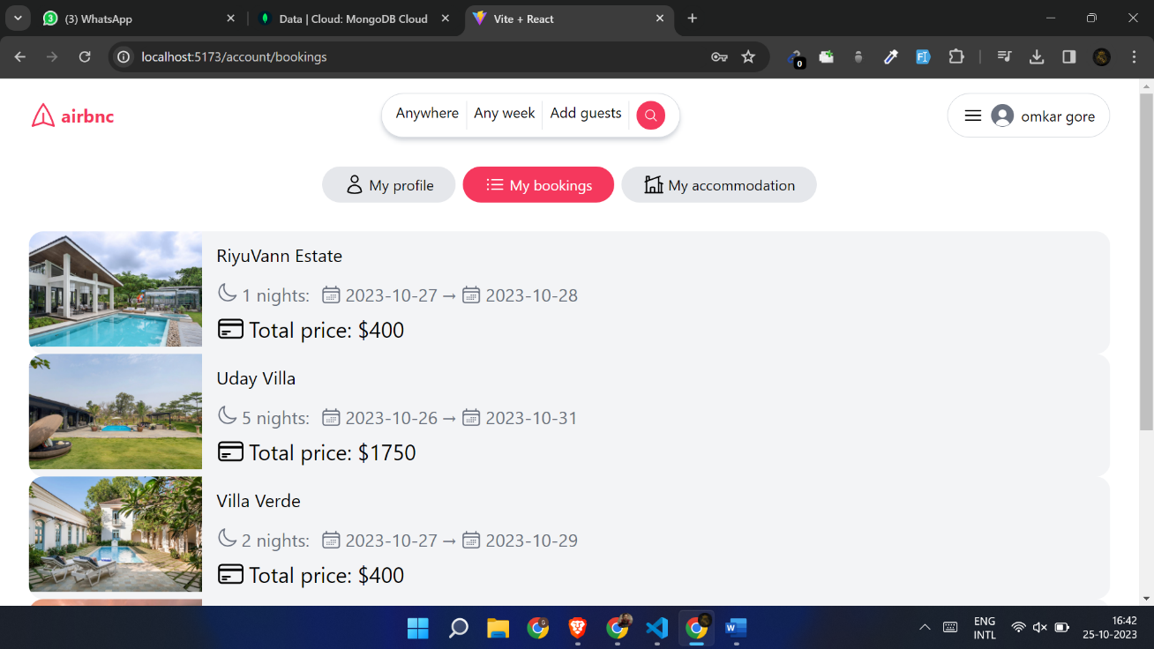

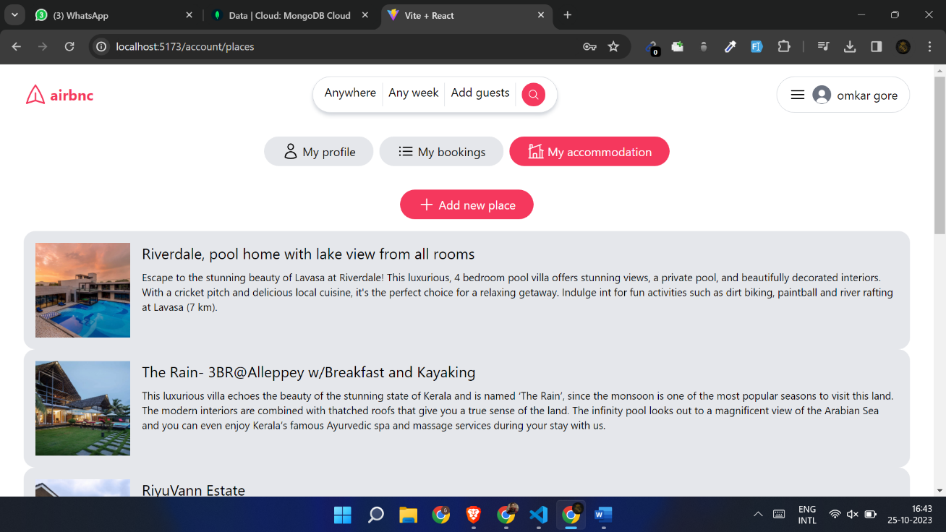

**7. CONCLUSIONS AND  FUTURE WORK**

In conclusion, the "Hotel Booking System" mini project has successfully demonstrated the development of a functional hotel booking platform. The use of the MERN stack and MongoDB has ensured a scalable and efficient system that can be expanded in the future. The system's user-friendly interface and key features provide valuable functionality to both customers and hotel administrators.

This project has opened the door to future enhancements and potential business opportunities. The commitment to ongoing development, user feedback, and adaptation to market trends will be essential in ensuring the continued success and growth of the "Hotel Booking System."

The project team is excited about the potential for further improvements and will continue to monitor the system's performance and address any issues that may arise. The goal is to offer a top-notch hotel booking experience to users and contribute to the hospitality industry's digital transformation.

**7.1 Future Work**

* **User Reviews and Ratings:** Allow users to leave reviews and ratings for hotels and rooms. Implement a review system with user-generated feedback to help others make informed decisions.
* **Advanced Search and Filters:** Enhance the search functionality with advanced filters such as price range, room types, amenities, and customer ratings.
* **Payment Integration:** Implement a payment gateway to enable online payments for bookings. Ensure secure payment processing for users.
* **Discounts and Promotions:** Create a system for offering discounts, promotions, and special deals for users, such as loyalty programs or promo codes.
* **Mobile Application:** Develop a mobile app (iOS and Android) for users to easily access and book hotels on the go.
* **Real-Time Availability:** Implement real-time room availability updates to avoid overbooking and provide accurate information to users.
* **Administrative Dashboard:** Improve the admin interface with data analytics, reporting tools, and the ability to manage reservations more efficiently.
* **Geolocation Services:** Use geolocation to help users find hotels and nearby attractions, restaurants, and transportation options.
* **Multi-Language Support:** Offer multilingual support to attract a global audience and make the system accessible to users from different regions.

**8. REFERENCES**

[1] Wei Wei , Zhengwei Lou , Design and Implementation of Hotel Room Management System

(20 February 2020). 2019 IEEE Symposium Series on Computational Intelligence (SSCI).

https://ieeexplore.ieee.org/document/9002651.

[2] Z. W. Miao; T. Wei; Y. Q. Lan , Hotel's online booking segementation for heterogenous customers (29 December 2016). 2016 IEEE International Conference on Industrial Engineering and Engineering Management (IEEM). Electronic ISSN: 2157-362X. https://ieeexplore.ieee.org/document/7798197.

**LINKS**

* REACT JS Documentation: <https://react.dev/learn>
* TAILWIND CSS: <https://tailwindcss.com/docs/guides/create-react-app>
* MONGOOSE JS: <https://mongoosejs.com/docs/documents.html>
* EXPRESS JS Documentation: <https://expressjs.com/en/5x/api.html>
* NODE JS : <https://nodejs.org/en>
* AXIOS (HTTP CLIENT) : <https://www.npmjs.com/package/axios>
* YOUTUBE:  <https://www.youtube.com/watch?v=MpQbwtSiZ7E>